*FREEDOM IN ACTION MINISTRY*

SUNDAY AFTERNOON WORSHIP SERVICES 2:30 PM

ON FACEBOOK

702-232-4750

**THIS WEEK’S SERMOn**

**another look at christmas**

**luke 2:1-12**

**UPDATE ON OUR NEW VENUE**

**WE HAD AMAZING SERVICES IN JULY AT WESTMINSTER PRESBYTERIAN CHURCH. THERE WERE TESTIMONIES OF PHYSICAL HEALINGS, EMOTIONAL HURTS HEALED, AND SO MANY WERE ENCOURAGED.**

**thank YOU, LORD!**

**COME AND JOIN US!**

**WE ARE HERE TO LOVE YOU AND ACCEPT YOU.**

**WE ARE CALLED TO SHARE GOD’S TRUTH WITH YOU!**

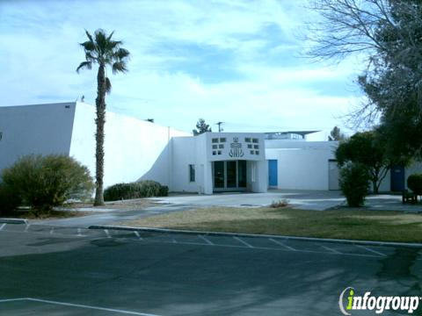

**REV. Marie WILL share the Word:**

**Every Saturday**

**AT WESTMINSTER PRESBYTERIAN CHURCH**

**4601 W. LAKE MEAD BOULEVARD**

**LAS VEGAS, NEVADA 89108**

**CLOTHING DISTRIBUTION AND**

**A PREPARED MEAL TO FOLLOW THE SERVICE**

**REV. MARIE TOMBOW IS ALSO A PUBLISHED AUTHOR!**

our team is here to serve you!

**Rev. Marie**

**Rev. Charles Rev. Sherry**

**Min. Suzy**

**UPDATE ON REVEREND MARIE**

**god is keeping his word. she is getting good reports from her doctors! THE DOCTORS HAVE SAID THE VASCULITIS IS OFFICIALLY IN REMISSION! In about 3 weeks tests will be run to see where we are with this ….. prayers, please……**

**she gives god all the glory!**

**WE SERVE A LIVING, A LOVING, AND A HEALING GOD!**

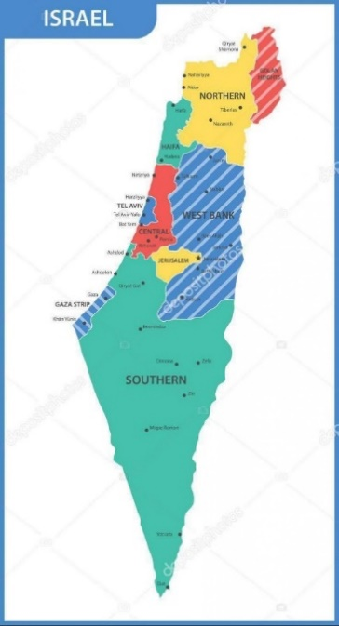

**WE ARE CONTINUING TO PRAY FOR THE NATION OF ISRAEL**

**PSALM 122:6 “Pray for the peace of Jerusalem! May they be secure who love YOU. PRAY FOR PRIME MINISTER NETANYAHU FOR GOD’S DIRECTION FOR THE PEOPLE OF THE COUNTRY!**

**YOU ARE INVITED TO FOLLOW US ON OUR WEBSITE**

**FREEDOMINACTIONMINISTRY.COM**

**PLEASE LEAVE:**

**COMMENTS – TESTIMONIES - PRAYER REQUESTS**

**YOU CAN ALSO DONATE TO THE MINISTRY ON THIS PAGE!**

**THANK YOU TO ALL THAT HAVE GENEROUSLY GIVEN TO THIS MINISTRY. WE APPRECIATE YOU. DONATIONS ARE USED TO BUY FOOD, CLOTHING AND HYGIENE PRODUCTS FOR THOSE IN NEED!**

**>>>>>>>>>>>>>>>>>>>>>>>>>>>>>>>>>>>**

**>>>>>>>>>>>>>>>>>>>>>>>>>>>>>>>>>>>>>>>>>>>>**

REMEMBER GOD LOVES YOU

AND SO DO WE!

**THIS IS WHAT THE LORD HAS SHOWN REVEREND MARIE**

**JOIN US ON OUR JOURNEY OF DISCOVERING… GOD’S LOVE.**

**this journey allows us to leave**

**THE BROKENNESS and bondage of rejection**

**and move into the freedom and wholeness**

**we discover in acceptance**

**– acceptance of who god created us to be.**

**PLEASE PRAY FOR OUR PRESIDENT AND LEADERS OF OUR**

**COUNTRY!**

**we are approaching a new year so let us keep our prayers and praises coming!**

BIRTHDAY CORNER

december

BIRTHDAYS

shelly

<https://www.facebook.com/share/p/rZWw6MR3avKYGZ7y/>

>>>>>>>>>>>>>>>>>>>>>>>>>>>>>>>>>>>>>>>>>>>

come join us