FREEDOM IN ACTION MINISTRY
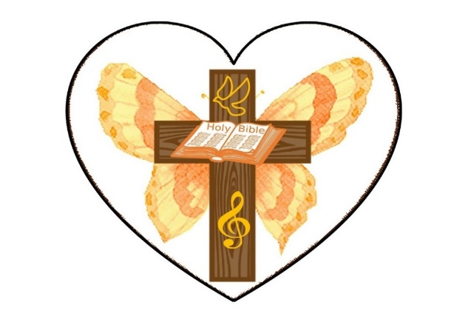

SUNDAY AFTERNOON WORSHIP SERVICES 2:30 PM
ON FACEBOOK
THURSDAY BIBLE STUDY 4PM AT OUR HOME!
CALL FOR DIRECTIONS
702-232-4750
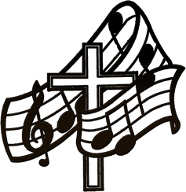
THIS WEEK’S SERMON
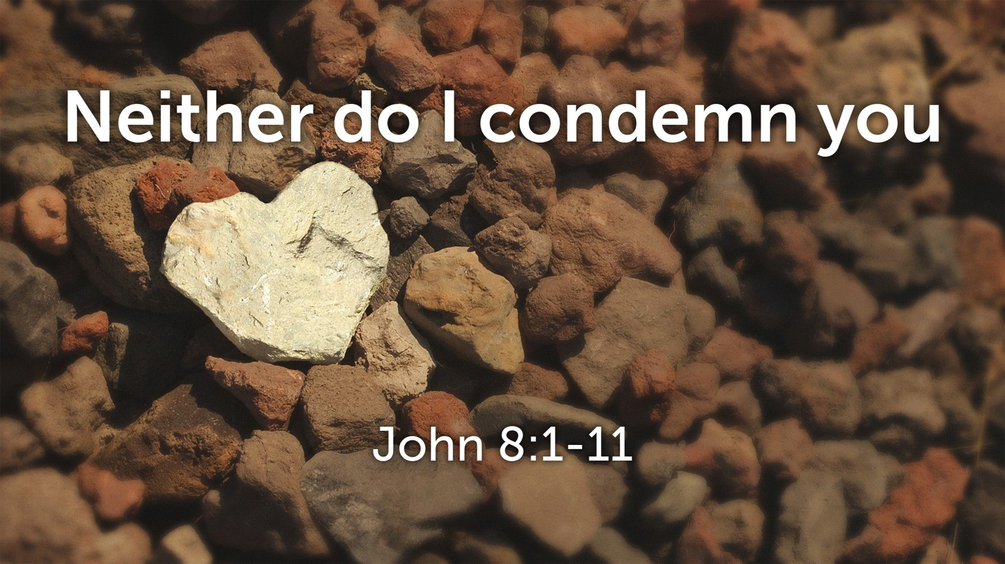

UPDATE ON OUR NEW VENUE
WE HAD AMAZING SERVICES IN JULY AT WESTMINSTER PRESBYTERIAN CHURCH. THERE WERE TESTIMONIES OF PHYSICAL HEALINGS, EMOTIONAL HURTS HEALED, AND SO MANY WERE ENCOURAGED. WE ARE TAKING SOME TIME OFF FOR A FEW WEEKS DUE TO THE EXTREME HEAT. WE WILL CONTINUE WITH CHURCH SATURDAY, SEPTEMBER 7TH AT 2:30 PM. THANK YOU, LORD!
COME AND JOIN US!
WE ARE HERE TO LOVE YOU AND ACCEPT YOU.
WE ARE CALLED TO SHARE GOD’S TRUTH WITH YOU!
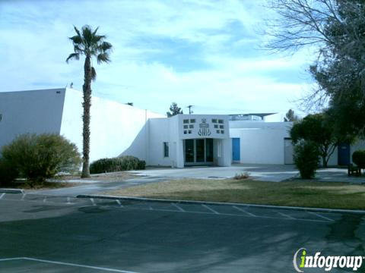
REV. Marie WILL share the Word:
Every Saturday STARTING
September 7th, 2024 @ 2:30pm
AT WESTMINSTER PRESBYTERIAN CHURCH
4601 W. LAKE MEAD BOULEVARD
LAS VEGAS, NEVADA 89108
CLOTHING DISTRIBUTION AND
A PREPARED MEAL TO FOLLOW THE SERVICE

REV. MARIE TOMBOW IS ALSO A PUBLISHED AUTHOR!
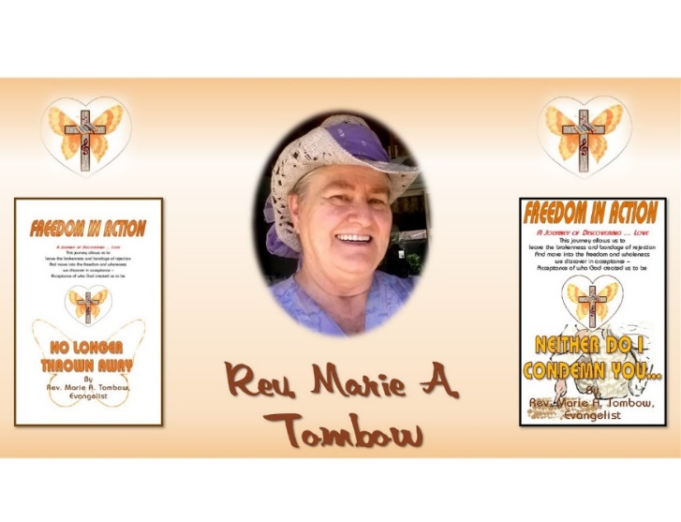

our team is here to serve you!
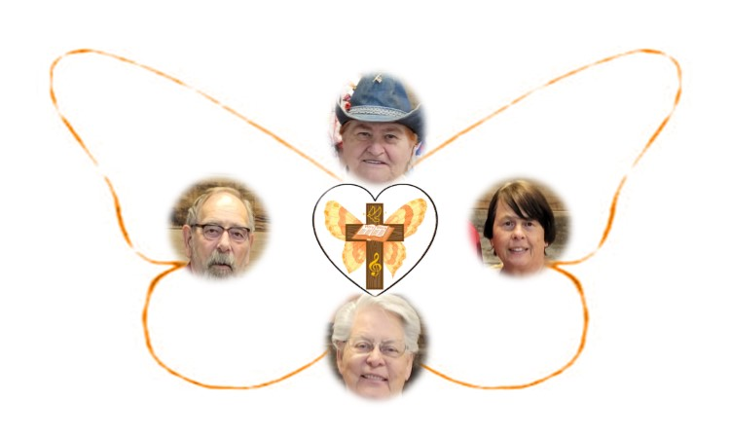
Rev. Marie

Rev. Charles Rev. Sherry

Min. Suzy
UPDATE ON REVEREND MARIE
god is keeping his word. she is getting good reports from her doctors! THE DOCTORS HAVE SAID THE VASCULITIS IS OFFICIALLY IN REMISSION! In about 3 weeks tests will be run to see where we are with this ….. prayers, please……
she gives god all the glory!
WE SERVE A LIVING, A LOVING, AND A HEALING GOD!

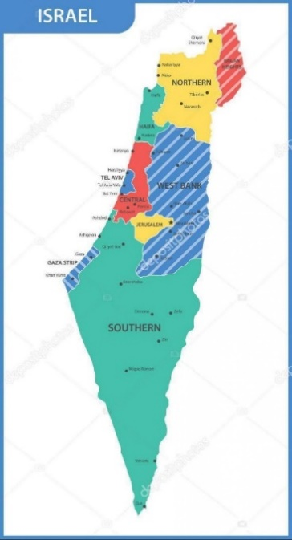

WE ARE CONTINUING TO PRAY FOR THE NATION OF ISRAEL
PSALM 122:6 “Pray for the peace of Jerusalem! May they be secure who love YOU. PRAY FOR PRIME MINISTER NETANYAHU FOR GOD’S DIRECTION FOR THE PEOPLE OF THE COUNTRY!

YOU ARE INVITED TO FOLLOW US ON OUR WEBSITE
FREEDOMINACTIONMINISTRY.COM
PLEASE LEAVE:
COMMENTS – TESTIMONIES - PRAYER REQUESTS
YOU CAN ALSO DONATE TO THE MINISTRY ON THIS PAGE!
THANK YOU TO ALL THAT HAVE GENEROUSLY GIVEN TO THIS MINISTRY. WE APPRECIATE YOU. DONATIONS ARE USED TO BUY FOOD, CLOTHING AND HYGIENE PRODUCTS FOR THOSE IN NEED!
>>>>>>>>>>>>>>>>>>>>>>>>>>>>>>>>>>>

>>>>>>>>>>>>>>>>>>>>>>>>>>>>>>>>>>>>>>>>>>>>
- THURSDAY BIBLE STUDY 4 pm
JOIN US – CALL FOR LOCATION
702-232-4750
WE ARE CURRENTLY STUDYING
THE BOOK OF ACTS
THE CHURCH IS THE BODY OF CHRIST
SEE HOW IT ALL BEGAN
COME JOIN US!
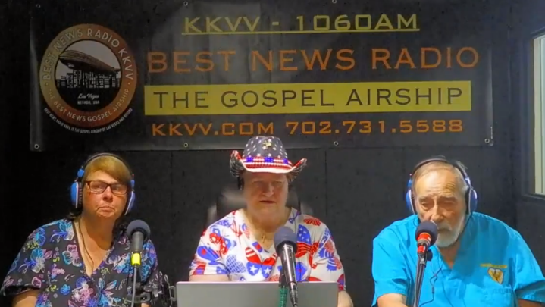

PLEASE LISTEN IN: KKVV AM RADIO 1060 ON YOUR DIAL AT 12:00 PM.
WE WILL BE DOING INTERVIEWS ON KKVV VERY SOON. STAY TUNED FOR THE DATES.
REV. MARIE AND REV. SHERRY WILL BE SHARING.
REMEMBER GOD LOVES YOU
AND SO DO WE!

THIS IS WHAT THE LORD HAS SHOWN REVEREND MARIE
JOIN US ON OUR JOURNEY OF DISCOVERING… GOD’S LOVE.
this journey allows us to leave
THE BROKENNESS and bondage of rejection
and move into the freedom and wholeness
we discover in acceptance
– acceptance of who god created us to be.

PLEASE PRAY FOR OUR PRESIDENT AND LEADERS OF OUR
COUNTRY!
ELECTION IS IN NOVEMBER
REMEMBER TO VOTE!
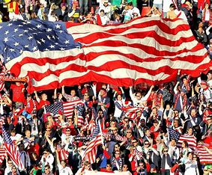

BIRTHDAY CORNER
AUGUST BIRTHDAYS

