*FREEDOM IN ACTION*

CHURCH

**FREEDOM IN ACTION CHURCH**

SUNDAY AFTERNOON WORSHIP SERVICES 2:30 PM

THURSDAY BIBLE STUDY 4PM AT OUR HOME!

CALL FOR DIRECTIONS

702-232-4750



**BRING YOUR FAMILY AND FRIENDS**

**THIS WEEK’S SERMON:**

**BLESSED IS THE NATION**

**ISAIAH 33:10-12**

**juLY 6TH, 2024 at 2:30 pm**

**freedom in action ministry**

**UPDATE ON OUR NEW VENUE**

**WE HAD AN AMAZING SERVICE LAST SATURDAY AT WESTMINSTER PRESBYTERIAN CHURCH. THERE WERE TESTIMONIES OF PEOPLE GETTING PHYSICALLY HEALED, EMOTIONAL HURTS HEALED, AND MANY WERE ENCOURAGED. THANK YOU, LORD!**

**COME AND JOIN US.**

**LET THE HOLY SPIRIT TOUCH YOUR HEART!**

**WE ARE HERE TO LOVE YOU AND ACCEPT YOU.**

**WE ARE CALLED TO SHARE GOD’S TRUTH WITH YOU!**

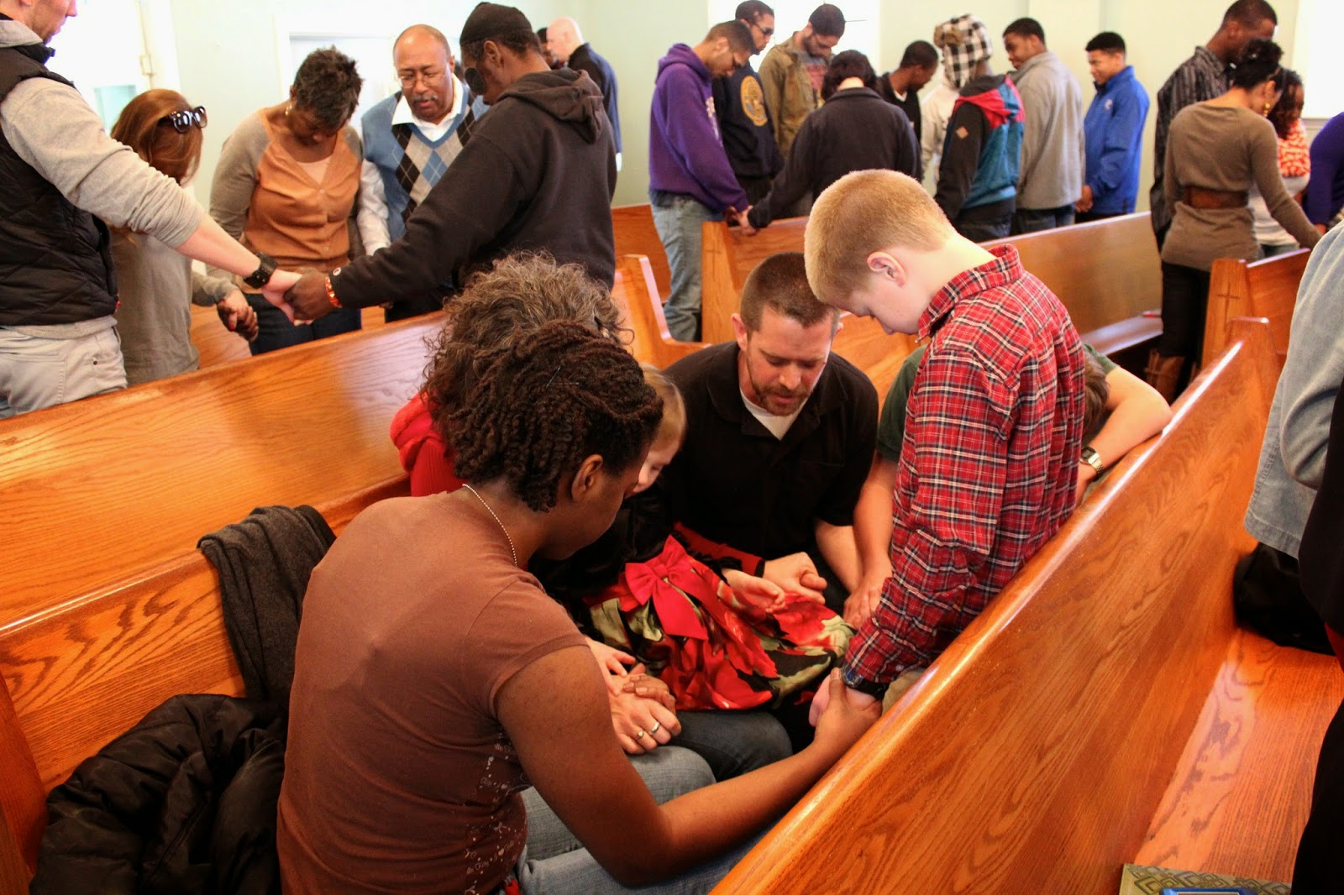

**SERVICE IS HELD AT WESTMINSTER PRESBYTERIAN**

**CHURCH**

**4601 W. LAKE MEAD BLVD**

**LAS VEGAS**

OUR MINISTRY TEAM

our team is here to serve you!

**WE ARE HERE TO SERVE YOU!**

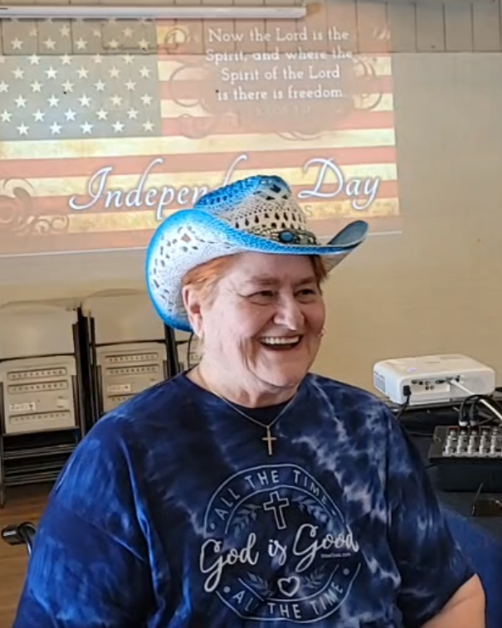

UPDATE ON REVEREND MARIE

**god is keeping his word. she is getting good reports from her doctors! THE DOCTORS HAVE SAID THE VASCULITIS IS IN REMISSION.**

**she gives god all the glory!**

**WE ARE CONTINUING TO PRAY FOR THE NATION OF ISRAEL**

**PSALM 122:6 “Pray for the peace of Jerusalem! May they be secure who love you!”**

**>>>>>>>>>>>>>>>>>>>>>>>>>>>>>>>>>>>>**

**PRAISE REPORT**

**FREEDOM IN ACTION MINISTRY HAS BEEN BLESSED WITH A NEW VENUE.**

**WESTMINSTER PRESBYTERIAN CHURCH**

**4601 W. LAKE MEADE BOULEVARD**

**LAS VEGAS, NEVADA 89108**

**EVERY SATURDAY AT 2:30 P.M.**

**TEACHING THE WORD OF GOD**

**WORSHIP**

**FREE HOT FOOD AND CLOTHING DISTRIBUTION TO FOLLOW.**

**EVERYONE IS INVITED!**

**SEE YOU THERE!**

**2:30 AT WESTMINSTER PRESBYTERIAN CHURCH**

**>>>>>>>>>>>>>>>>>>>>>>>>>>>>>>>>>>**

**YOU ARE INVITED TO FOLLOW US ON OUR BULLETIN PAGE**

**FREEDOMINACTIONMINISTRY.COM**

**PLEASE LEAVE:**

**COMMENTS**

**TESTIMONIES**

**PRAYER REQUEST**

**YOU CAN ALSO DONATE TO THE MINISTRY ON THIS PAGE!**

**THANK YOU TO ALL THAT HAVE GENEROUSLY GIVEN TO THIS MINISTRY. WE APPRECIATE IT. DONATIONS ARE USED TO BUY FOOD, CLOTHING AND HYGIENE PRODUCTS FOR THOSE IN NEED!**

***FREEDOMINACTIONMINISTRY.COM***

**>>>>>>>>>>>>>>>>>>>>>>>>>>>>>>>>>>>**



**WE WOULD LOVE FOR YOU TO JOIN US**

**EVERY SUNDAY AT**

**2:30 PM ON FACEBOOK**

**>>>>>>>>>>>>>>>>>>>>>>>>>>>>>>>>>>>>>>>>>>>>**

- **THURSDAY BIBLE STUDY 4 pm**

**JOIN US – CALL FOR LOCATION**

WE ARE CURRENTLY STUDYING

THE BOOK OF ACTS

THE CHURCH IS THE BODY OF CHRIST

SEE HOW IT ALL BEGAN

**COME JOIN US!**

**THIS IS WHAT THE LORD HAS SHOWN REVEREND MARIE**



**JOIN US ON OUR JOURNEY OF DISCOVERING… GOD’S LOVE.**

**this journey allows us to leave**

**THE BROKENNESS and bondage of rejection**

**and move into the freedom and wholeness**

**we discover in acceptance**

**– acceptance of who god created us to be.**

WE WILL BE DOING INTERVIEWS ON KKVV VERY SOON. STAY TUNED FOR THE DATES.

REV. MARIE AND REVEREND SHERRY WILL BE SHARING.

PLEASE LISTEN IN: KKVV AM RADIO 1060 ON YOUR DIAL AT 12:00 PM.

>>>>>>>>>>>>>>>>>>>>>>>>>>>>>>>>>>>>>>>>



OUR NEW VENUE



MEETING AT WESTMINSTER PRESBYTERIAN CHURCH



4601 W. LAKE MEAD BLVD

CHURCH SERVICE SATURDAYS AT



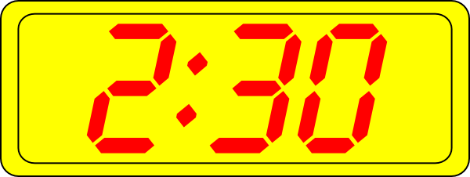LAS VEGAS, NV 89108

WESTMINSTER PRESBYTERIAN CHURCH

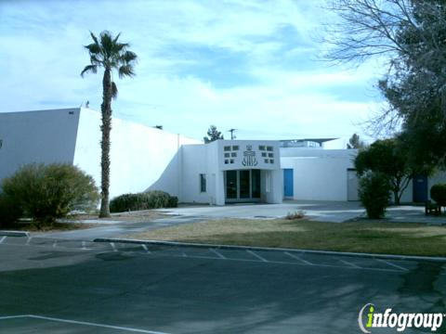

REMEMBER GOD LOVES YOU

AND SO DO WE!

BIRTHDAY CORNER

JULY BIRTHDAYS

TEAM LEADER NORMA

JULY 7TH

HAPPY BIRTHDAY NORMA