*FREEDOM IN ACTION*

CHURCH

**FREEDOM IN ACTION CHURCH**

SUNDAY AFTERNOON WORSHIP SERVICES 2:30 PM

THURSDAY BIBLE STUDY 4PM



**BRING YOUR FAMILY AND FRIENDS**

**THIS WEEK’S SERMON:**

**The promise of god’s presence**

**isaiah 43:1-3**

**june 23rd, 2024 at 2:30 pm**

**freedom in action ministry**

**our new venue**

**located at:**

**westminster presbyterian church**

**4601 w. lake mead blvd**

**las vegas, nevada 89108**

REV. MARIE WILL BE TEACHING SUNDAY!

JOIN US ON FACEBOOK AT 2:30 PM

WE WOULD LIKE TO HEAR FROM YOU. PLEASE SHARE SOME COMMENTS WITH US.

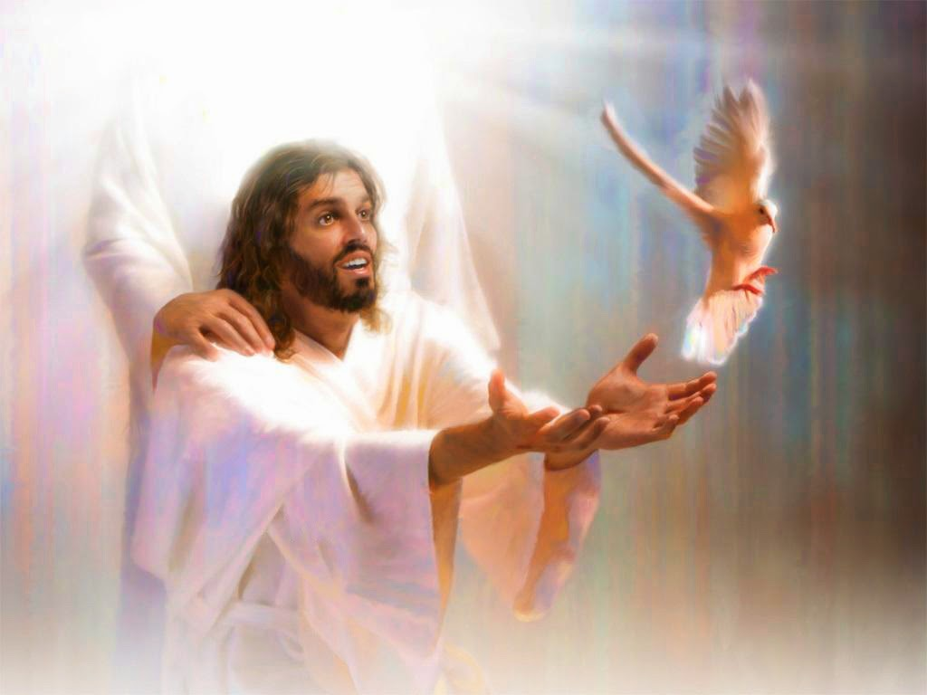

[Don't shine so that others can see you. Shine so that through you, others can see HIM.](https://www.azquotes.com/quote/877335)

[**C. S. Lewis**](https://www.azquotes.com/author/8805-C_S_Lewis)

**

our team is here to serve you!

**CONTINUED PRAYER FOR REVEREND MARIE TOMBOW AT THIS TIME. SHE NEEDS PHYSICAL HEALING.**

**update:**

**god is keeping his word. she is getting good reports from her doctors!**

**pray for the vasculitis to disappear. she gives god all the glory!**

**LET US BE IN PRAYER FOR OUR CHURCHES:**

**THEIR SAFETY**

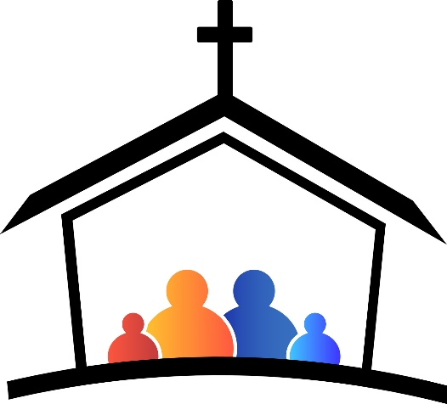**THEIR DISCERNING AND TEACHING THE TRUTH**

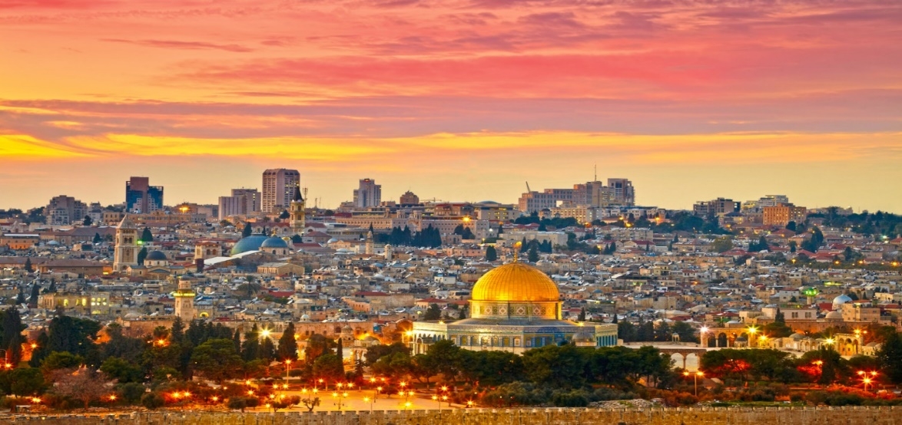

**WE ARE CONTINUING TO PRAY FOR THE NATION OF ISRAEL**

**PSALM 122:6 “Pray for the peace of Jerusalem! May they be secure who love you!”**

**>>>>>>>>>>>>>>>>>>>>>>>>>>>>>>>>>>>>**

**PRAISE REPORT**

**FREEDOM IN ACTION MINISTRY HAS BEEN BLESSED WITH A NEW VENUE .**

**WESTMINSTER PRESBYTERIAN CHURCH**

**4601 W. LAKE MEADE BOULEVARD**

**LAS VEGAS, NEVADA 89108**

**EVERY SATURDAY AT 2:30 P.M.**

**TEACHING THE WORD OF GOD**

**WORSHIP**

**FREE HOT FOOD AND CLOTHING DISTRIBUTION TO FOLLOW.**

**EVERYONE IS INVITED!**

**SEE YOU THERE!**

**2:30 AT WESTMINSTER PRESBYTERIAN CHURCH**

**4601 W. LAKE MEAD BLVD**

**>>>>>>>>>>>>>>>>>>>>>>>>>>>>>>>>>>**

**YOU ARE INVITED TO FOLLOW US ON OUR BULLETIN PAGE**

**FREEDOMINACTIONMINISTRY.COM**

**PLEASE LEAVE:**

**COMMENTS**

**TESTIMONIES**

**PRAYER REQUEST**

**YOU CAN ALSO DONATE TO THE MINISTRY ON THIS PAGE!**

***FREEDOMINACTIONMINISTRY.COM***

**>>>>>>>>>>>>>>>>>>>>>>>>>>>>>>>>>>>**



**WE WOULD LOVE FOR YOU TO JOIN US**

**EVERY SUNDAY AT**

**2:30 PM ON FACEBOOK**

- **THURSDAY BIBLE STUDY 4 pm**

**JOIN US – CALL FOR LOCATION**

WE ARE CURRENTLY STUDYING

THE BOOK OF ACTS

THE CHURCH IS THE BODY OF CHRIST

SEE HOW IT ALL BEGAN

**COME JOIN US!**

**ALL OUR WELCOME!**



**JOIN US ON OUR JOURNEY OF DISCOVERING… GOD’S LOVE.**

**this journey allows us to leave**

**THE BROKENNESS and bondage of rejection**

**and move into the freedom and wholeness**

**we discover in acceptance**

**– acceptance of who god created us to be.**

**>>>>>>>>>>>>>>>>>>>>>>>>>>>>>>>>>>>>>>>>**

**BIRTHDAYS IN JUNE**

**who wants to join the birthday page?**

**REV. MARIE TOMBOW – JUNE 8TH**





WE WILL BE DOING INTERVIEWS ON KKVV VERY SOON. STAY TUNED FOR THE DATES.

REV. MARIE AND REVEREND SHERRY WILL BE SHARING.

PLEASE LISTEN IN: KKVV AM RADIO 1060 ON YOUR DIAL AT 12:00 PM.

>>>>>>>>>>>>>>>>>>>>>>>>>>>>>>>>>>>>>>>>



OUR NEW VENUE



MEETING AT WESTMINSTER PRESBYTERIAN CHURCH



4601 W. LAKE MEAD BLVD

CHURCH SERVICE SATURDAYS AT



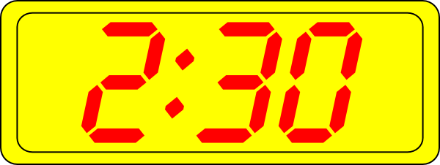LAS VEGAS, NV 89108

WESTMINSTER PRESBYTERIAN CHURCH

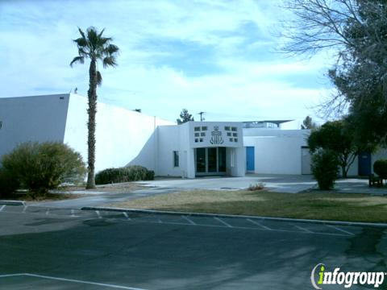

REMEMBER GOD LOVES YOU

AND SO DO WE!