FREEDOM IN ACTION
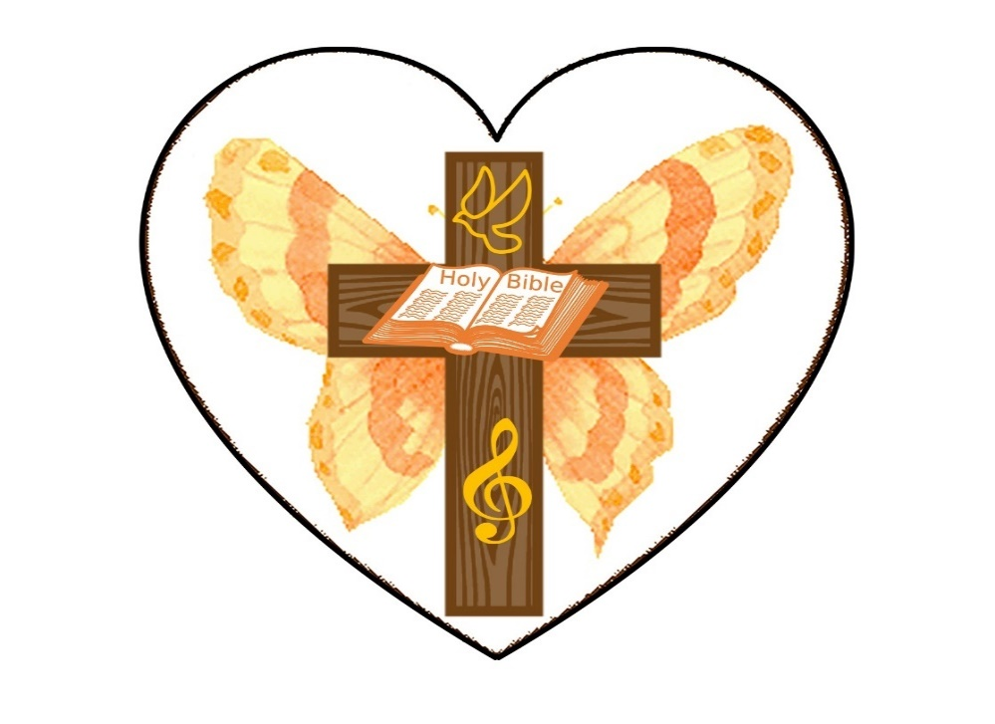
CHURCH

FREEDOM IN ACTION CHURCH
SUNDAY AFTERNOON WORSHIP SERVICES 2:30 PM

THURSDAY BIBLE STUDY 4PM


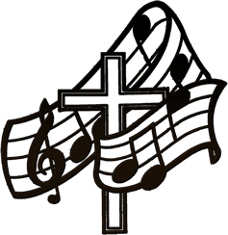
BRING YOUR FAMILY AND FRIENDS

THIS WEEK’S SERMON:
pentecost
the holy spirit and what he gives

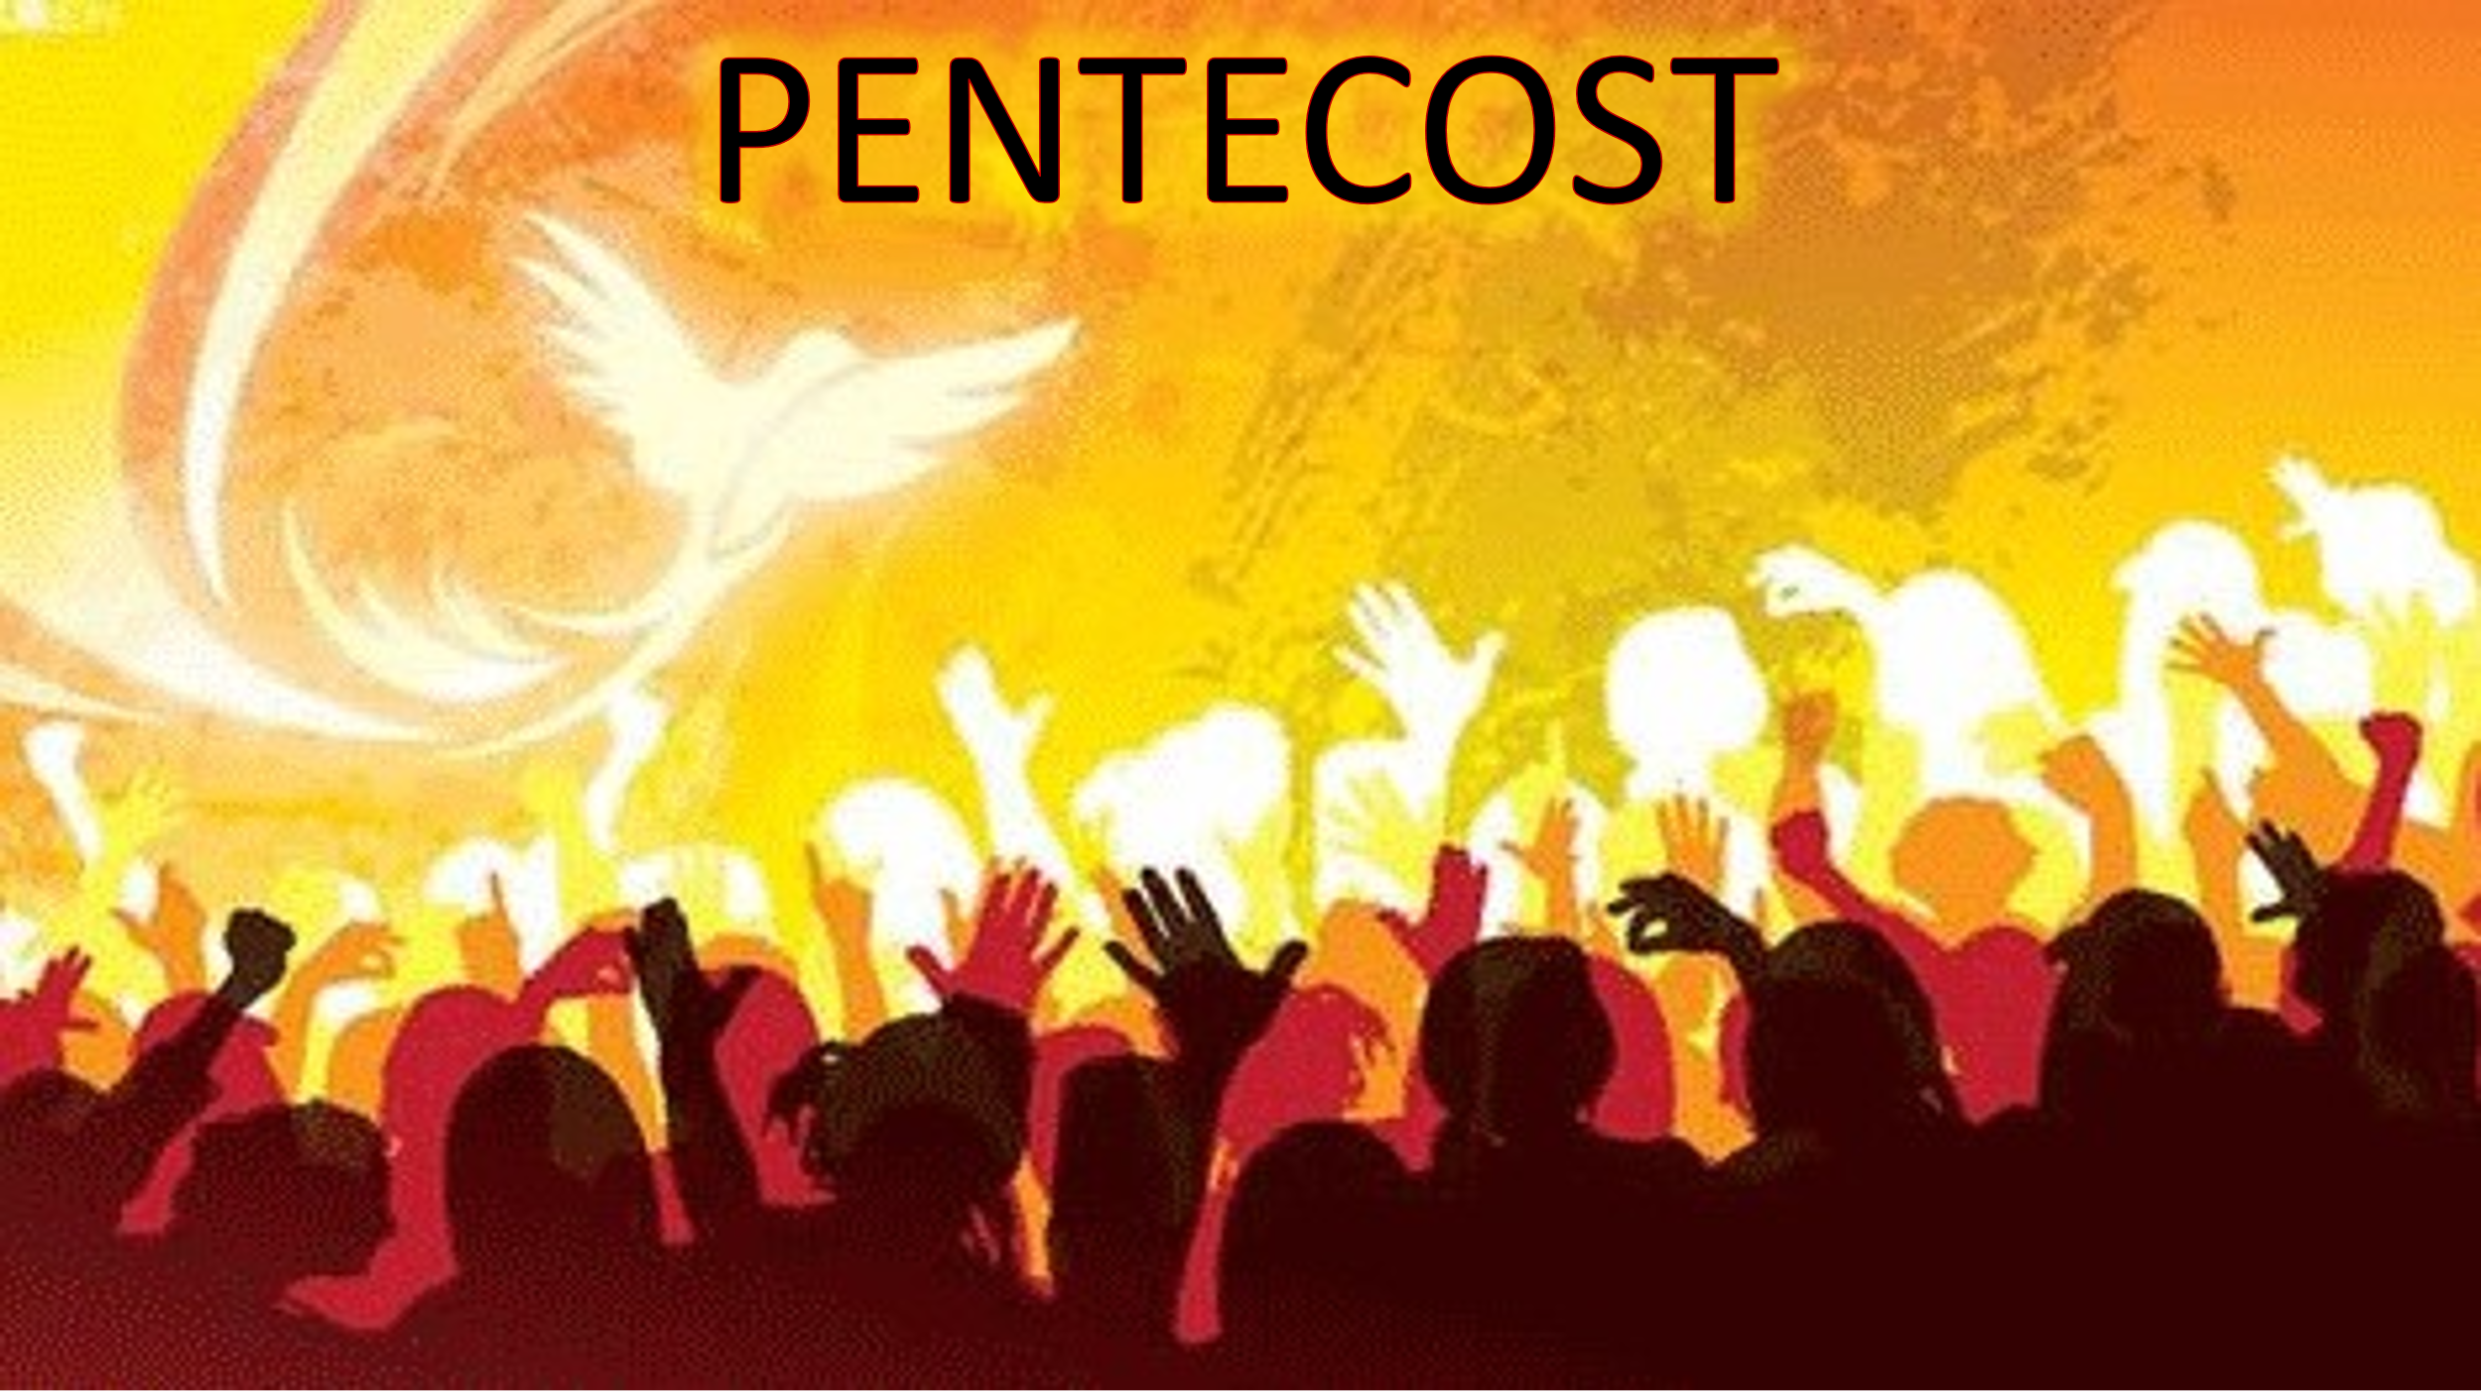

REV. MARIE WILL BE TEACHING SUNDAY!
JOIN US ON FACEBOOK AT 2:30 may 19th, 2024
WE WOULD LIKE TO HEAR FROM YOU. PLEASE SHARE SOME COMMENTS WITH US.

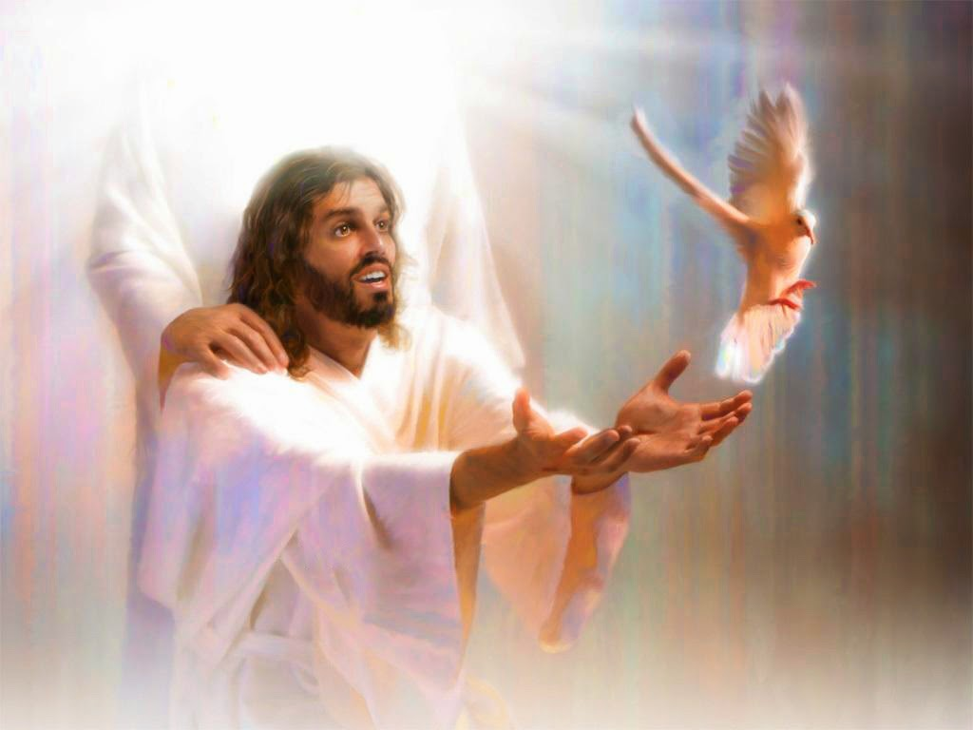

What Scripture lays stress on is not men’s circumstances, but their moral and spiritual condition.

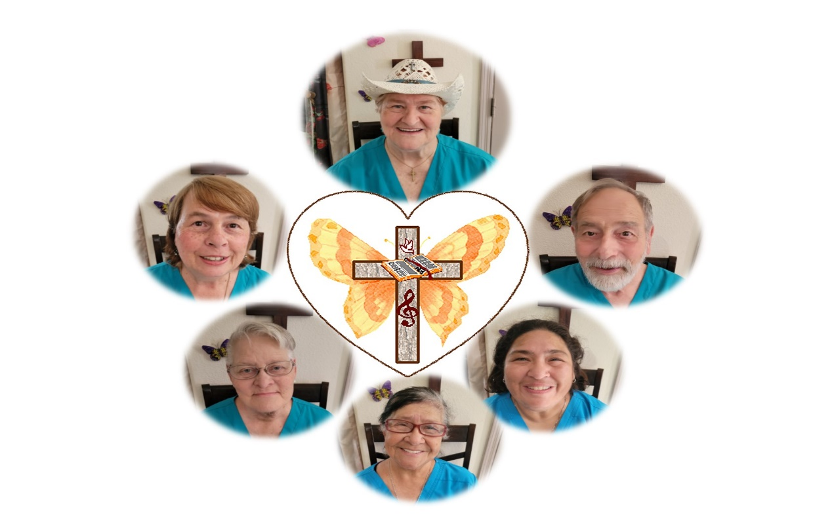
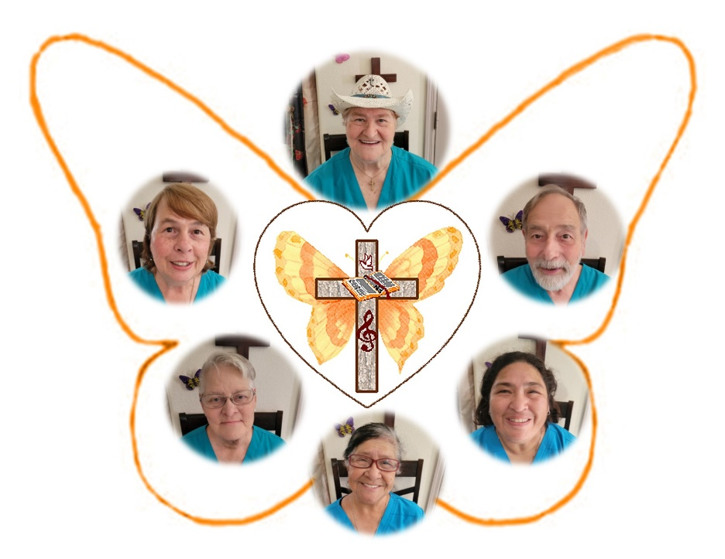

our team is here to serve you!



CONTINUED PRAYER FOR REVEREND MARIE TOMBOW AT THIS TIME. SHE NEEDS PHYSICAL HEALING.
update:
rev. Marie is doing much better! pray for the vasculitis to disappear. she gives god all the glory!
LET US BE IN PRAYER FOR OUR CHURCHES:
THEIR SAFETY
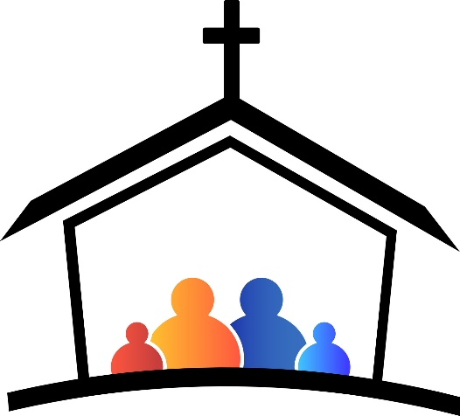
THEIR DISCERNING AND TEACHING THE TRUTH

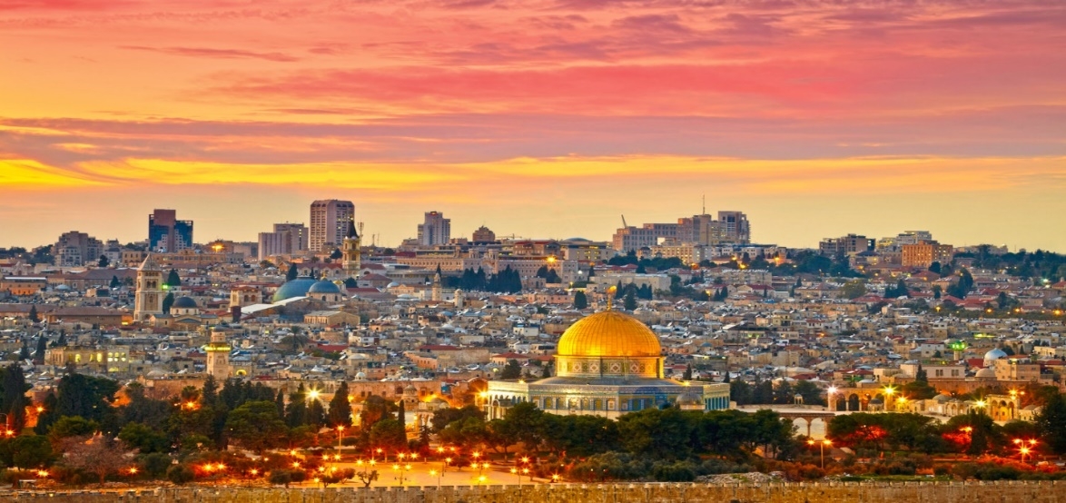

WE ARE CONTINUING TO PRAY FOR THE NATION OF ISRAEL
PSALM 122:6 “Pray for the peace of Jerusalem! May they be secure who love you!”
>>>>>>>>>>>>>>>>>>>>>>>>>>>>>>>>>>>>
PRAISE REPORT
FREEDOM IN ACTION MINISTRY HAS BEEN BLESSED WITH A NEW VENUE STARTING JUNE 8TH, 2024.
WESTMINSTER PRESBYTERIAN CHURCH
4601 W. LAKE MEADE BOULEVARD
LAS VEGAS, NEVADA 89108
EVERY SATURDAY AT 2:30 P.M.
TEACHING THE WORD OF GOD
WORSHIP
FREE FOOD TO FOLLOW AND CLOTHING!
EVERYONE IS INVITED!
SEE YOU THERE!

>>>>>>>>>>>>>>>>>>>>>>>>>>>>>>>>>>
YOU ARE INVITED TO FOLLOW US ON OUR BULLETIN PAGE
FREEDOMINACTIONMINISTRY.COM
PLEASE LEAVE:
COMMENTS
TESTIMONIES
PRAYER REQUEST
YOU CAN ALSO DONATE TO THE MINISTRY ON THIS PAGE!

FREEDOMINACTIONMINISTRY.COM
>>>>>>>>>>>>>>>>>>>>>>>>>>>>>>>>>>>


WE WOULD LOVE FOR YOU TO JOIN US
EVERY SUNDAY AT
2:30 PM ON FACEBOOK

- THURSDAY BIBLE STUDY 4 pm
JOIN US – CALL FOR LOCATION
WE ARE CURRENTLY STUDYING
THE BOOK OF ACTS
THE CHURCH IS THE BODY OF CHRIST
SEE HOW IT ALL BEGAN

COME JOIN US!
ALL OUR WELCOME!

JOIN US ON OUR JOURNEY OF DISCOVERING… GOD’S LOVE.
this journey allows us to leave
THE BROKENNESS and bondage of rejection
and move into the freedom and wholeness
we discover in acceptance
– acceptance of who god created us to be.
>>>>>>>>>>>>>>>>>>>>>>>>>>>>>>>>>>>>>>>>
BIRTHDAYS IN may


who wants to join the birthday page?

WE ARE EXCITED TO ANNOUNCE OUR NEXT RADIO BROADCAST!
may 9th, 2024
WE WILL BE DOING INTERVIEWS ON KKVV VERY SOON. STAY TUNED FOR THE DATES.
REV. MARIE AND REVEREND SHERRY WILL BE SHARING.
PLEASE LISTEN IN: KKVV AM RADIO 1060 ON YOUR DIAL AT 12:00 PM.





