*FREEDOM IN ACTION*

CHURCH

**FREEDOM IN ACTION CHURCH**

SUNDAY AFTERNOON WORSHIP SERVICES 2:30 PM

THURSDAY BIBLE STUDY 4PM

**BRING YOUR FAMILY AND FRIENDS**

**THIS WEEK’S SERMON:**

**the holy spirit and what he does**

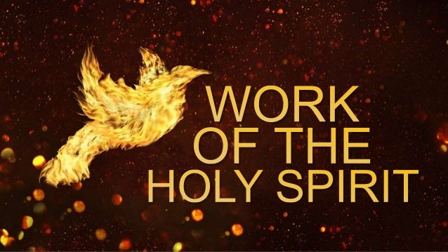

REV. MARIE WILL BE TEACHING SUNDAY!

JOIN US ON FACEBOOK AT 2:30 may 5th, 2024

**What Scripture lays stress on is not men’s circumstances, but their moral and spiritual condition.**

**

our team is here to serve you!

**CONTINUED PRAYER FOR REVEREND MARIE TOMBOW AT THIS TIME. SHE NEEDS PHYSICAL HEALING.**

**update:**

**rev. Marie is doing much better! pray for the vasculitis to disappear. she gives god all the glory!**

**LET US BE IN PRAYER FOR OUR CHURCHES:**

**THEIR SAFETY**

**THEIR DISCERNING AND TEACHING THE TRUTH**

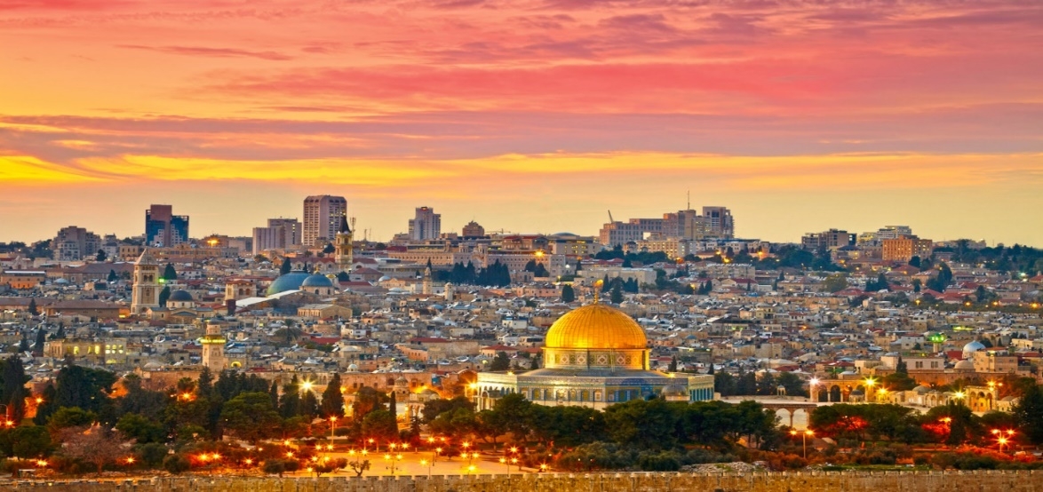

**WE ARE CONTINUING TO PRAY FOR THE NATION OF ISRAEL**

**PSALM 122:6 “Pray for the peace of Jerusalem! May they be secure who love you!”**

**PLEASE JOIN US IN PRAYER FOR A NEW VENUE – A PHYSICAL LOCATION WHERE WE CAN BETTER SERVE THE COMMUNITY.**

**>>>>>>>>>>>>>>>>>>>>>>>>>>>>>>>>>>**

**YOU ARE INVITED TO FOLLOW US ON OUR BULLETIN PAGE**

**FREEDOMINACTIONMINISTRY.COM**

**PLEASE LEAVE:**

**COMMENTS**

**TESTIMONIES**

**PRAYER REQUEST**

**YOU CAN ALSO DONATE TO THE MINISTRY ON THIS PAGE!**

***FREEDOMINACTIONMINISTRY.COM***



**WE WOULD LOVE FOR YOU TO JOIN US**

**EVERY SUNDAY AT**

**2:30 PM ON FACEBOOK**

- **THURSDAY BIBLE STUDY 4 pm**

**JOIN US – CALL FOR LOCATION**

WE ARE CURRENTLY STUDYING

THE BOOK OF ACTS

THE CHURCH IS THE BODY OF CHRIST

SEE HOW IT ALL BEGAN

**COME JOIN US!**

**ALL OUR WELCOME!**



**JOIN US ON OUR JOURNEY OF DISCOVERING… GOD’S LOVE.**

**this journey allows us to leave**

**THE BROKENNESS and bondage of rejection**

**and move into the freedom and wholeness**

**we discover in acceptance**

**– acceptance of who god created us to be.**

**>>>>>>>>>>>>>>>>>>>>>>>>>>>>>>>>>>>>>>>>**

**BIRTHDAYS IN may**

**who wants to join the birthday page?**



**WE ARE EXCITED TO ANNOUNCE OUR NEXT RADIO BROADCAST!**

**may 9th, 2024**

WE WILL BE DOING INTERVIEWS ON KKVV STARTING NEXT WEEK.

REV. MARIE AND REVEREND SHERRY WILL BE SHARING.

PLEASE LISTEN IN: KKVV AM RADIO 1060 ON YOUR DIAL AT 12:00 PM.

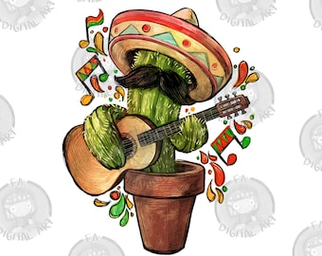

>>>>>>>>>>>>>>>>>>>>>>>>>>>>>>>>>>>>>>>>

happy cinco de mayo!